**写作指导**

**如何描写未来的生活**

**写作任务 (Section B 3c)**

本周英语角的主题是畅想20年以后的生活。请你从20年后你所从事的工作、居住地、环境、交通方式、业余活动等方面进行畅想，写一篇短文，为此次活动做准备。

**●【审清题目】**

**内容：**从工作、居住地、交通方式、环境、业余活动等方面描写自己20年后的生活

**文体：**说明文

**时态：**以一般将来时为主

**人称：**第一人称

**●【头脑风暴】**

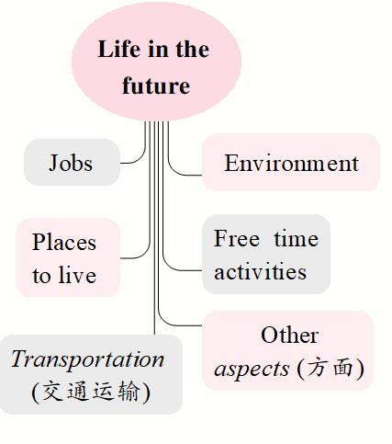

**●【提供素材】**

**◆单词&短语&句子**根据汉语提示，写出对应的英文表达。

|  |  |
| --- | --- |
| **What will my life be like in 20 years?** | |
| **Jobs** | teacher, scientist, (1)______________(医生), bus driver, cook, engineer, pilot, violinist, pianist, (2)______________(编程人员), actor, basketball player, astronaut  ·I think I will be a reporter / ...  ·I'm going to be a nurse / ... |
| **Places to live** | look for another planet to live on, (3)______________(建造更多的空间站), build houses under the sea, live on the moon  ·There will be robot servants at the homes of the future.  ·Smaller and more environmentally-friendly houses will be more popular.  ·Cities will be more crowded / ... |
| **Transportation** | cars [run on new and clean fuel (燃料)]  ·Cars and buses will fly around the city.  ·(4)______________(人们会有自己的飞机).  ·Most people will use space rockets (they will fly from one side of the planet to another in an hour).  ·Everyone has a self-driving car. |
| **Environment** | short of water, (5)______________(空气污染), less clean air (people have to pay for clean air), fresher / cleaner air, fewer / more trees, more buildings  ·The weather will be much hotter / worse / ...  ·There will be more / fewer people / cars / trees / ... |
| **Free time activities** | (6)______________(去月球度假), go for walks in space  ·People will have much more free time / have more holidays / have talking animal friends / ... |
| **Other aspects** | use energy (能源) for free, world peace, no more disease (疾病), (7)______________(活到150岁以上), work at most three days a week, work at home  ·People will get along well with robots (see robots everywhere).  ·(8)______________(学生将在网上学习).  ·Students won't have to go to school.  ·E-books will replace (取代) traditional books.  ·Paper money will be less and less.  ·Everything will be free. |

**Keys:** 1. doctor  2. computer programmer  3. build more space stations

4. People will have their own planes  5. air pollution

6. go to the moon for a holiday / go on a holiday to the moon

7. live to be over / more than 150 years old  8. Students will study online

**●【谋篇布局】**将括号内的汉语翻译成英语，补全短文。

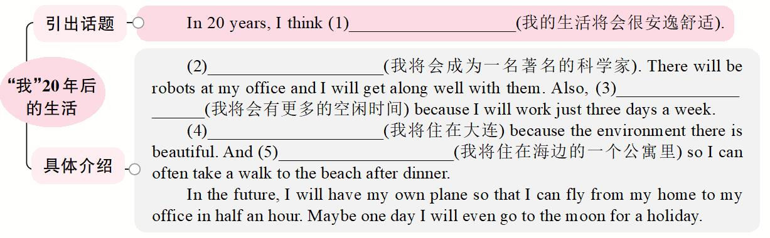

**Keys:**

1. my life will be easy / comfortable

2. I will be / become a famous scientist

3. I will have more free time

4. I will live in Dalian

5. I will live in an apartment by / near the sea